Batch:B4 Roll No.: 16010122221

Experiment / assignment / tutorial No._______

TITLE : To study and implement Non-Restoring method of division

AIM : The basis of algorithm is based on paper and pencil approach and the operation involve repetitive shifting with addition and subtraction. So the main aim is to depict the usual process in the form of an algorithm.
______________________________________________________________________
Expected OUTCOME of Experiment: (Mention CO/CO’s attained here)

To better understand the non-restoring algorithm and executing it using a programming
language. To find the advantage of non-restoring over restoring division.

_____________________________________
Books/ Journals/ Websites referred:

- Carl Hamacher, Zvonko Vranesic and Safwat Zaky, “Computer Organization”, Fifth Edition, TataMcGraw-Hill.
- William Stallings, “Computer Organization and Architecture: Designing for Performance”, Eighth Edition, Pearson.
3. Dr. M. Usha, T. S. Srikanth, “Computer System Architecture and Organization”, First Edition, Wiley-India.
_____________________________________________________________________
Pre Lab/ Prior Concepts:
The Non Restoring algorithm works with any combination of positive and negative numbers.
Flowchart for Non-Restoring of Division( Students need to draw)

Flowchart for Non-Restoring of Division:

Example: (Handwritten solved problem needs to uploaded)

CODE:
#include <stdio.h>
#include <math.h>
#include <stdlib.h>

int findbit(int m, int q) {
m = abs(m) > abs(q) ? abs(m) : abs(q);
int q_copy = q;
int count = 0;
while (pow(2, count) < m) {
count++;
}
return count > 4 ? count : 4;
}

int* binary(int a, int num) {
int* ptr = (int*)malloc(num * sizeof(int));
int acopy = abs(a);
int check = 1;

for (int i = 0; i < num; i++) {
ptr[i] = acopy % 2;
acopy = acopy / 2;
}

if (a < 0) {
for (int i = 0; i < num; i++) {
if (ptr[i] == 1 && check == 1) {
check = 0;
}
else if (ptr[i] == 1 && check == 0) {
ptr[i] = 0;
}
else if (ptr[i] == 0 && check == 0) {
ptr[i] = 1;
}
}
}

return ptr;
}

void printbinary(int* ans, char* s, int num) {
for (int i = (2 * num) - 1; i > num - 1; i--) {
printf("%d ", ans[i]);
}
printf("\t");

for (int i = num - 1; i >= 0; i--) {
printf("%d ", ans[i]);
}
printf("\t%s\n", s);
}

void binaryadd(int* ans, int* n, int num) {
int carry = 0;
for (int i = num; i < 2 * num; i++) {
if (ans[i] + n[i - num] + carry == 1) {
ans[i] = 1;
carry = 0;
}
else if (ans[i] + n[i - num] + carry == 2) {
ans[i] = 0;
carry = 1;
}
else if (ans[i] + n[i - num] + carry == 3) {
ans[i] = 1;
carry = 1;
}
}
}

int main() {
int m, q;
printf("Enter Q and M: ");
scanf("%d %d", &q, &m);

int num = findbit(m, q);
int ans[2 * num];
int *arr = binary(q, num);

for (int i = num - 1; i >= 0; i--) {
ans[i] = arr[i];
}

printf("\nA\t\tQ\t\tOperation\n\n");
printbinary(ans, "Initial Value", num);

for (int i = 0; i < num; i++) {
if (ans[2 * num - 1] == 1) {
for (int j = 2 * num; j > 0; j--) {
ans[j] = ans[j - 1]; // left Shifting
}
printbinary(ans, "Shift Left", num);
binaryadd(ans, binary(m, num), num);
printbinary(ans, "A <- A + M", num);
}
else {
for (int j = 2 * num; j > 0; j--) {
ans[j] = ans[j - 1]; // left Shifting
}
printbinary(ans, "Shift Left", num);
binaryadd(ans, binary(-m, num), num);
printbinary(ans, "A <- A - M", num);
}
if (ans[2 * num - 1] == 1) {
ans[0] = 0;
printbinary(ans, "Qo = 0", num);
}
else {
ans[0] = 1;
printbinary(ans, "Qo = 1", num);
}
}
if (ans[2 * num - 1] == 1) {
binaryadd(ans, binary(m, num), num);
printbinary(ans, "A <- A + M", num);
}
printbinary(ans, "Final Answer", num);

return 0;
}

OUTPUT:
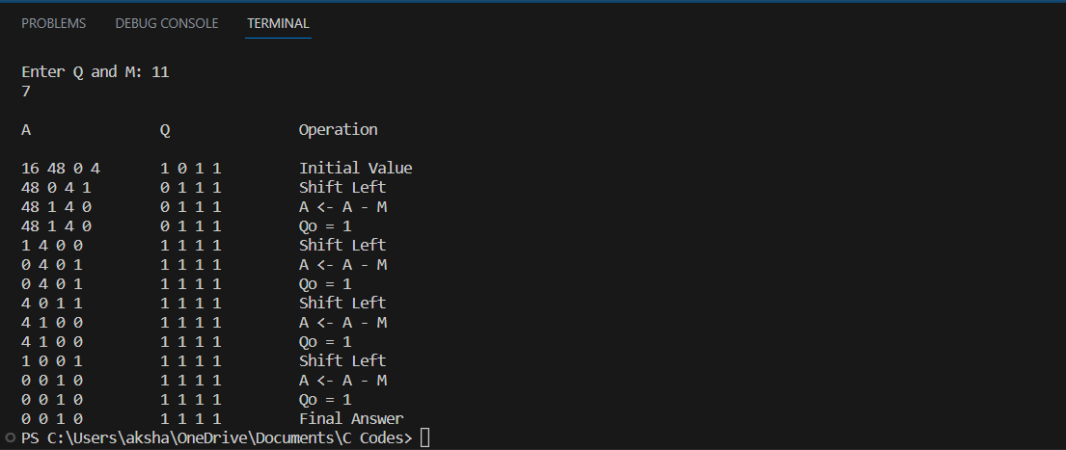

Conclusion
Successfully executed and coded the algorithm for non-restoring division. In this
experiment, Non-Restoring Division Algorithm is executed with the help of C
programming.
The advantage of Non-Restoring Division over Restoring Division is better understood.

Post Lab Descriptive Questions
What are the advantages of non-restoring division over restoring division?
Non-restoring division uses the digit set {−1, 1} for the quotient digits instead
of {0, 1}. Non-Restoring Division when implemented in hardware, there is only one
decision and addition/subtraction per quotient bit; there is no restoring step after the
subtraction, which potentially cuts down the numbers of operations by up to half and
lets it be executed faster.
Restoring method: you add the divisor back, and put 0 as your next quotient digit
Non-restoring method: you don’t do that - you keep negative remainder and a digit
1, and basically correct things by a supplementary addition afterwards.

